**Homepage Requirements**

**1. Customer vs Product: Total Customers per Product**

* **Component**: Bar Chart / Pie Chart
* **Data Points**:
  1. Product Names
  2. Total Number of Customers for each Product

**2. State vs Customer vs Product**

* **Component**: Interactive US Map with Popups
* **Data Points**:
  1. States
  2. Total Customers per State
  3. Products per State
* **Popup Details**:
  1. Total Customers
  2. Yearly Customer Trend (Line Chart)
  3. Product Division (Pie Chart)

**3. Gender Representation**

* **Component**: Pie Chart
* **Data Points**:
  1. Gender (Male, Female, Other)
  2. Number of Customers per Gender

**4. Age Representation**

* **Component**: Bar Chart
* **Data Points**:
  1. Age Groups (18-25, 26-50, 51-60, 60+)
  2. Number of Customers per Age Group

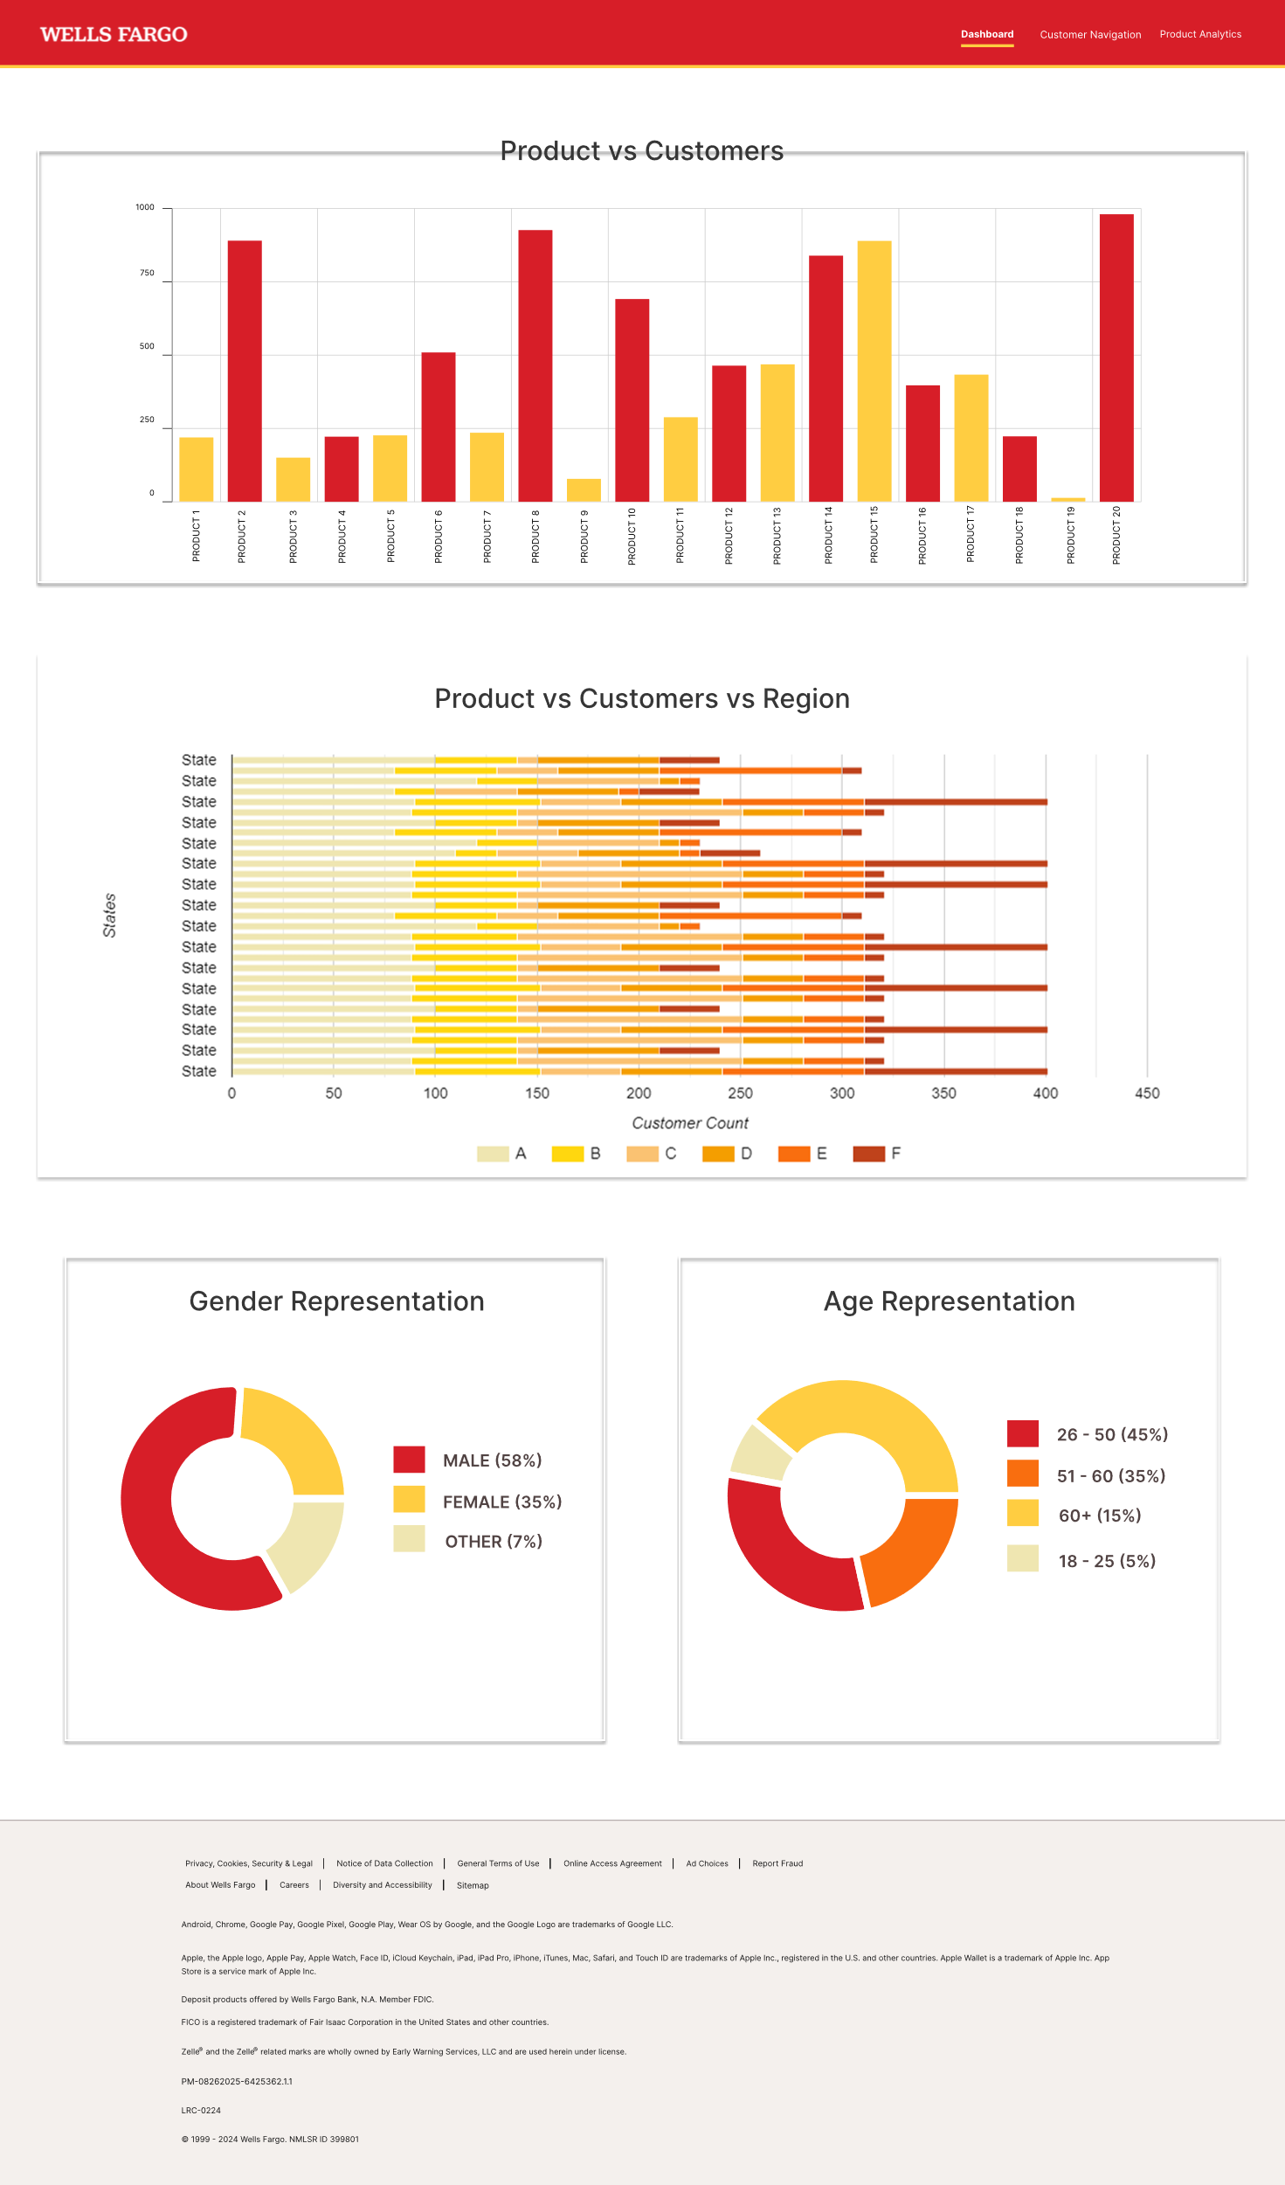

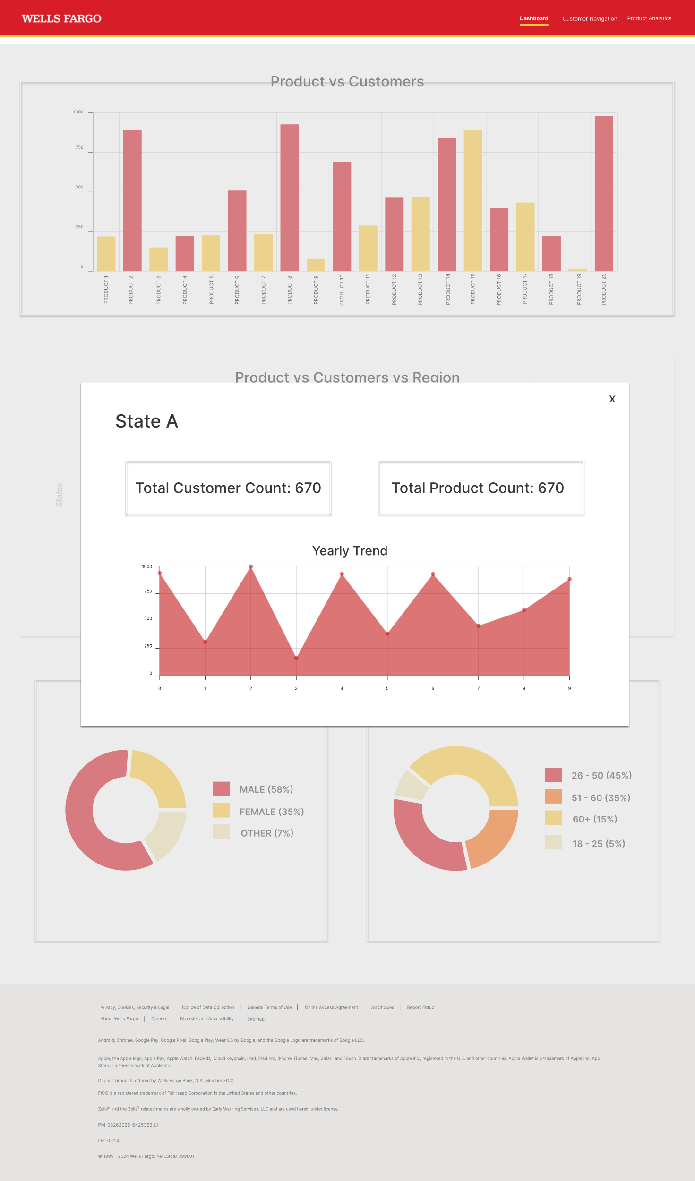

**Product Analytics**

**Pre-Filter/Existing Element**

* **Component**: US Map
* **Data Points**:
  1. Regions
  2. Customer Volume per Region

**Filters**

1. **Search by Product**

**Component**: Search Bar

1. **Filter by Product Type + Subtype**

**Component**: Dropdown Menu

**Options**: e.g., Trade, Annuity, Stocks, Intermediate

1. **Select Category**

**Component**: Dropdown Menu

**Options**: e.g., IRA, Foreign, etc

**Graphs**

1. **Total Customers for the Product**

**Component**: Bar Chart

1. **Region vs Customers for the Product**

**Component**: Heat Map / Bar Chart

1. **Yearly Customer Trend for the Product**

**Component**: Line Chart

1. **Customer vs Age Group for the Product**

**Component**: Bar Chart

1. **Top 3 Regions**

**Component**: List / Bar Chart

**Customer Navigation**

**Pre-Filter/Existing Element**

* **Component**: Line Chart
* **Data Points**: Yearly Customer Trend

**Filters**

1. **Filter by Source of Wealth**

**Component**: Dropdown Menu

1. **Filter by Regions**

**Component**: Dropdown Menu / Map Selection

1. **Filter by Occupation**

**Component**: Dropdown Menu

**Post-Filter Details**

1. **Total Customers in the Category**

**Component**: Number Display

1. **Product Split**

**Component**: Pie Chart

1. **Top 3 Leading Occupations**

**Component**: List / Bar Chart

1. **Top 3 Regions**

**Component**: List / Bar Chart